August 29, 2024

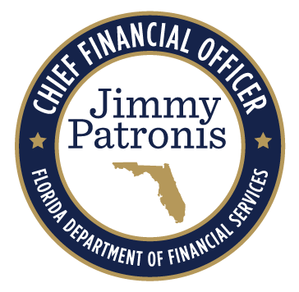

To: All Self-Insurers, Insurers, Claim Administrators, and Medical Service Providers
From: Florida Division of Workers' Compensation
Subject: Notice of Workshop for Rule 69L-7.020, F.A.C., Florida Workers’ Compensation Health Care Provider Reimbursement Manual

The Florida Division of Workers' Compensation announces a virtual Workshop for Rule 69L-7.020, F.A.C., Florida Workers’ Compensation Health Care Provider Reimbursement Manual that will be held Thursday, September 12, 2024, at 10:00 a.m. – 12:00 p.m., Eastern Time.

SUBJECT AREA TO BE ADDRESSED:
Draft version of the Florida Workers' Compensation Health Care Provider Reimbursement Manual, 2024 Edition. A draft copy of the Manual can be found here.
- A copy of the notice may be found here.
- A copy of the rule text may be found here.
- A copy of the agenda may be found here.
The official Notice appears in Volume 50, Number 170, of the Florida Administrative Register, published on August 29, 2024.

Location: This meeting will not be held in person.

Please join the meeting from your computer, tablet, or smartphone.
Microsoft Teams
Join the meeting now

Meeting ID: 232 691 572 649
Passcode: BnHPvi

Dial in by phone.
+1 850-328-4354,,262573154# United States, Tallahassee
(850) 328-4354,,262573154# United States (Toll-free)
Phone conference ID: 262 573 154#

If you have questions about the contents of this notice, please contact Charlene Miller, Bureau Chief of the Bureau of Monitoring and Audit, Division of Workers' Compensation at Charlene.Miller@myfloridacfo.com.

 | 

Florida Department of Financial Services | Division of Workers' Compensation
200 East Gaines Street, Tallahassee, FL 32399-4220
www.myfloridacfo.com/division/wc
Unsubscribe - Unsubscribe Preferences

